Introduction
George Bernard Shaw once said that “there is no sincerer love than the love of food.” However, sometimes that food doesn’t always love you back, and leaves you feeling far from your best the next day.
This isn’t always caused by a case of overindulgence; it could have been a result of an intolerance to something you have eaten or drunk.
Our handy guide will tell you everything you need to know about food intolerance, from what a food intolerance actually is to the most common forms and how to spot them.

What is Food Intolerance?
A food intolerance, or non-IgE mediated food hypersensitivity, is when someone develops symptoms after eating certain foods. In many cases, a reasonable amount of the offending food can be tolerated. However, if large portions are consumed regularly, a person may develop symptoms.
Many people confuse food intolerance with food allergy, but there are key differences between the two.
A food allergy is a rapid (and potentially serious) response to a food by your immune system, which can result in rashes, wheezing and itching. It is thought around one or two people out of every 100 in the UK have a food allergy.
Although food intolerance results in similar symptoms to allergies, your body doesn’t actually produce antibodies against the offending food.
Food intolerances are much more common than food allergies. It is estimated that around one in five Britons now believe they have a food intolerance. However, food intolerances are often self-diagnosed meaning this figure is difficult to accurately predict.
Food intolerance symptoms generally develop much more slowly, often many hours after eating the problem food. You can also be intolerant to several different foods, which makes identifying the foods that are causing the problem extremely difficult.
It can also be difficult to distinguish food intolerances from other digestive disorders that produce similar symptoms, such as inflammatory bowel disease, gastrointestinal obstructions or Irritable Bowel Syndrome (IBS).

What Causes Food Intolerance?

Food intolerance can have a number of different causes:

Additives in foods
The changes in our eating habits in recent years has meant many of us are eating more processed foods. These foods can contain a large variety of natural and artificial additives, such as colourants and preservatives, which some people have a hypersensitivity to, resulting in food intolerance symptoms.

Enzyme defects
Most foods require some enzyme activity in their digestion, and enzyme deficiencies can be an important factor in food intolerance.
Enzymes help to break down natural substances in certain foods. When these enzymes are lacking or not present in the body at all, parts of the food cannot be broken down and absorbed. This can trigger a variety of symptoms.
If you have a lactose intolerance, your body lacks the enzyme (lactase) that is responsible for breaking down lactose (milk sugar) into smaller sugars ready to be absorbed. Because lactose is a disaccharide, it needs to be broken down before it can be absorbed by the gut wall. When left undigested, it can cause panful symptoms like diarrhoea, spasms and bloating.

Toxic
There are a range of foods that contain naturally occurring substances that can exert a toxic effect, resulting in symptoms such as vomiting and diarrhoea.
For example, if chickpeas or kidney beans aren’t fully cooked, then this results in aflotoxins, causing the aforementioned symptoms. However, these toxins aren’t present if they are cooked properly.
This can add an element of confusion when people are trying to figure out why they seem to tolerate a food sometimes but not others.

Pharmacological
Naturally occurring chemicals are sometimes found in food. Present in items like coffee, tea and chocolate, these can have an effect on the body.
The impact these substances have varies from person to person. If someone has an intolerance to these chemicals, they may develop symptoms from eating just a small amount of the food. Others may be able to eat more without experiencing any symptoms at all.

Salicylates in foods
Found in a large proportion of foods, salicylates are widely eaten by many people. While the vast majority will suffer no symptoms, some people will experience problems if they eat too much of the foods that contain them.

Histamine in foods
Some foods contain naturally occurring histamine. Whereas others (such as certain types of fish that have not been stored properly and are no longer fresh) can develop a build-up of histamine in their flesh as they age.
For certain people, this histamine can cause problems when eaten. Common symptoms for sufferers include stomach pains, diarrhoea and vomiting. In more extreme cases, anaphylaxis-like symptoms may be experienced.

Most Common Food Intolerances in the UK


Lactose Intolerance – Avg. searches per month in UK (62,440)
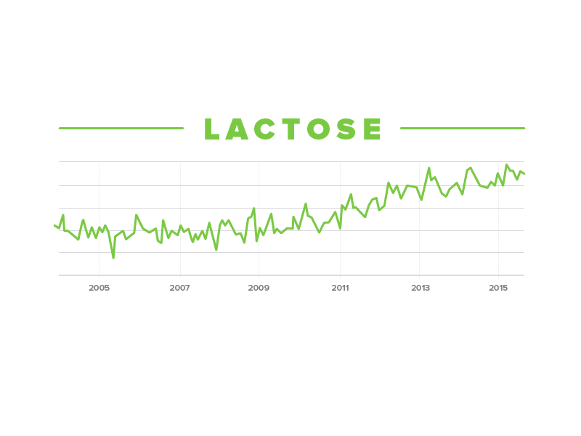
This is a relatively common complaint, and is more common in certain ethnic groups. Lactose intolerance arises due to an inability to digest lactose (milk sugar) because of low levels or an absence of lactase (the enzyme responsible for digesting lactose). Common symptoms of lactose intolerance are diarrhoea, bloating and general discomfort.

Gluten Intolerance - Avg. searches per month in UK (24,670)
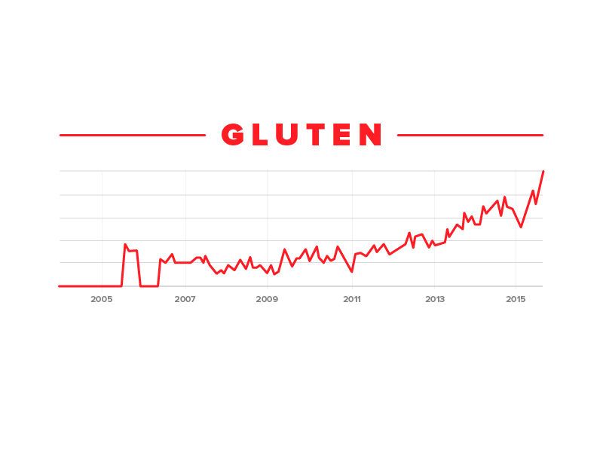
Gluten intolerance is where sufferers display symptoms when eating foods with ingredients containing gluten, such as wheat, barley and rye. This is sometimes referred to as ‘non-coeliac gluten sensitivity’.
Although the symptoms of gluten intolerance can be similar to those experienced by people with coeliac disease, gluten intolerance differs from coeliac disease mainly due to the apparent lack of damage to the lining of the gut in people with an intolerance to gluten.

Wheat Intolerance - Avg. searches per month in UK (15,410)
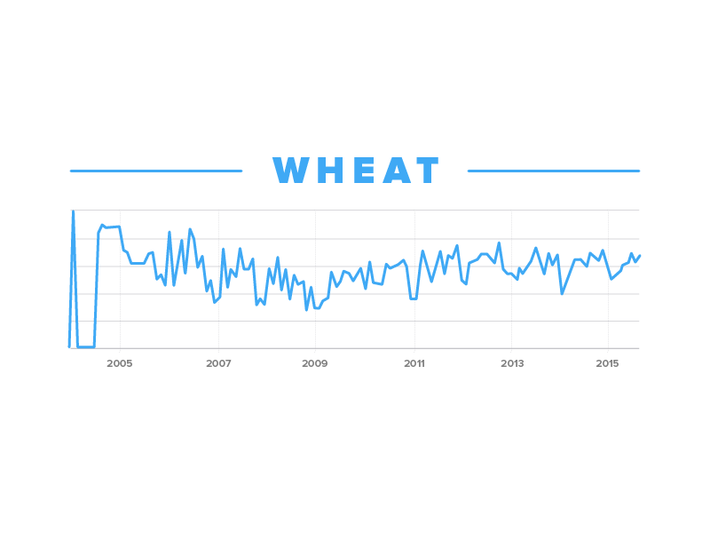
A few years ago, anyone looking to exclude wheat from their diet faced an uphill struggle to find suitable alternatives. Thankfully there is now much more awareness and products on the market that cater to special diets.
Although people with a wheat intolerance display similar symptoms to those with coeliac disease, including abdominal discomfort, nausea, tiredness, bloating and altered bowel habit, there are some key differences.
Coeliac disease is a lifelong intolerance to gliadin, a component of the proteins in gluten that gives bread the ability to rise properly during baking, and form a large part of wheat, rye, and barley grains. Those that strictly adhere to a gluten-free diet will experience a complete resolution of symptoms.
In contrast, those with wheat intolerance will still experience adverse symptoms from gluten free products, as they will still be affected by the remaining part of the wheat. People with wheat intolerance may, or may not, be able to eat rye, barley and oats, which are all part of the wheat family.

Alcohol Intolerance - Avg. searches per month in UK (3,240)
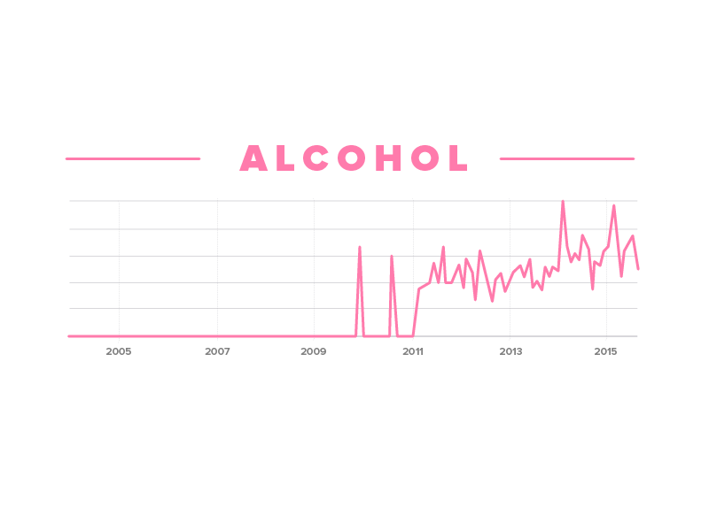Many people can experience symptoms as a result of an intolerance to alcohol. However, the real cause of their intolerance is extremely varied and complicated.
An intolerance to alcohol may be due to your body lacking an enzyme that results in an inability to properly digest and eliminate alcohol. If your body cannot effectively deal with the alcohol molecule, it can cause unusual symptoms to occur.
An added level of complexity comes from the fact that alcohol increases the absorbency of your gut, thereby allowing more food molecules into your body. This may be a reason why people with mild food insensitivity do not react to the food alone, only when it is combined with alcohol.
In some people the reaction can be very specific, such as an intolerance to a particular type of wine. For others, it can be caused by an intolerance to different varieties of alcohol.
People can also have an intolerance to the food on which a particular drink is based, such as the grapes used in wine, or the grains used in whisky. Alternatively, other people can have an intolerance to another substance in a particular alcoholic drink. These include:

Histamine
Histamine is present in a wide range of alcoholic drinks, especially red wines. An intolerance to histamine in alcohol can result in headaches, flushing, nasal symptoms, gut symptoms or asthma.

Sulphites/Sulphur Dioxide
Sulphur dioxide is extremely common in wines and home brewed-beers. It is used when cleaning equipment and the resulting brew can also contains very high levels. As asthmatics are particularly sensitive to sulphites, the most common symptom of an intolerance to sulphites is wheezing; anaphylactic reactions are also an extremely rare symptom.

Yeasts
Yeast is a key ingredient used in the brewing process for beer, and can be a cause of intolerance to alcoholic drinks. However, studies have shown that alcoholic drinks only contain low levels of yeast allergens.

Additives
Additives such as tartrazine (used in many alcopops) and sodium benzoate can trigger hives and welts, or wheezing.
If you do suffer from alcohol intolerance, avoidance is the primary method of controlling your symptoms. At the onset of a reaction, keep a record of the type of drink and any other food you have consumed. This will help you identify where the issues lie.

So what is Coeliac Disease? Is it an allergy or an intolerance?
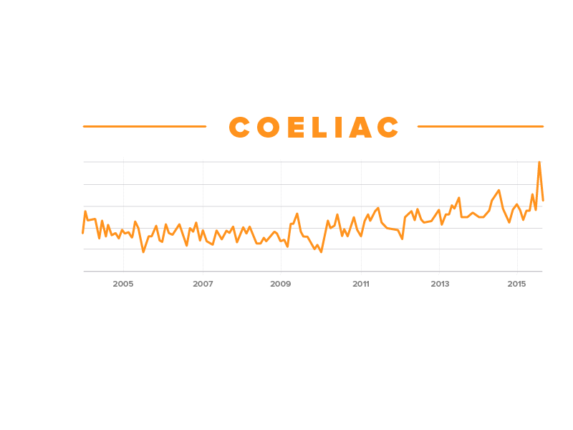
Coeliac disease isn't an allergy or an intolerance to gluten. It is a common digestive condition where a person has an adverse reaction to gluten, there are on average 49,210 searches for Coeliac Disease in the UK every month.
This adverse reaction is due to your body’s immune system mistaking substances found inside gluten as a threat to the body and attacking them. As a result, this damages the healthy tissue on the surface of your small bowel, thereby disrupting your body’s ability to absorb nutrients from food.
Eating foods containing gluten can trigger a range of symptoms that can range from mild to severe, such as:
- diarrhoea
- flatulence and bloating
- abdominal pain
- sudden weight loss
- hair loss
- lethargy as a result of not getting enough nutrients from the food you eat
- children not growing at the expected rate

Common Symptoms of Food Intolerance

Unfortunately, the symptoms caused by food intolerance are complex and varied.
There are relatively general symptoms such as a headaches and migraines, stuffy or runny nose, low mood, night sweats, lethargy and aching joints.
In addition, there are also skin symptoms, including rashes and eczema, as well as gastrointestinal symptoms, such as and vomiting, diarrhoea, bloating and irritable bowels.

Identification, Diagnosis & Treatment

Unfortunately, there currently aren’t any reliable and validated tests to identify food intolerance apart from the ones that are used to test for coeliac disease and lactose intolerance.
Due to this fact, exclusion diets, also referred to as diagnostic diets, are the main tool used to diagnose food intolerance.
There are a range of different factors that can cause food intolerance, but thankfully it is treatable once you have identified the reactive foods. Once you have eliminated all other possible causes, you should set about commencing a structured and supervised reintroduction.

If symptoms are not immediate
With food intolerance, the time between developing symptoms and eating food is contingent on multiple factors.
For example, if you only eat a food very occasionally, the onset of symptoms can vary from almost immediately to several hours after digestion.
In contrast, if you regularly consume a particular food, then each ‘reaction’ can overlap with the next, producing a ‘chain-reaction’ that can result in almost continual, chronic symptoms. The problem with this is that there is no discernible reaction to a food once it has been eaten, making it incredibly tricky to identify the culprit food.
However, identification is still readily achieved, which can often produce marked results.

If symptoms are usually multiple
When it comes to food intolerance, they can produce a much broader spectrum of symptom, with more than one symptom happening at the same time. Moreover, these can be extremely general and non-specific, resulting in extremely tricky diagnosis.
If this happens, you should aim to record everything you eat, and note when symptoms occur; this should allow you to spot correlations between foods eaten and the onset of symptoms.

Other factors
In rare cases, symptoms and food intolerances can be made worse by the presence of underlying medical conditions. If this is the case, the main priority should always be the treatment of the underlying condition as opposed to the intolerance. This will hopefully allow your symptoms to improve.
As always, you should seek the medical advice of your GP rather than attempting to self-diagnose or treat problems yourself.

Elimination followed by reintroduction
An exclusion diet, or diagnostic diet, involves excluding certain foods from your diet in order to find out what is causing symptoms. Exclusion diets require a lot of planning and dedication, but the results can be life changing.
While carrying out your exclusion diet, it is essential that you adhere to your plan 100%; you will have to restart the exclusion phase if any mistakes are made in order to maintain the integrity and validity of your results.
The process for this diet is as follows:
- Begin by excluding one or several foods from your diet for a set period of time (usually between two to six weeks depending on symptoms)*
- See if the symptoms improve or resolve during this time.
- If they do, slowly reintroduce these foods back into your diet to see if symptoms return, so that a clear diagnosis can be made.
*Whilst you are embarking on your exclusion diet, it is important to replace the foods you are excluding with other foods of similar nutritional composition. If you are unsure about this, it is best to seek the advice of a dietitian.

Prolonged elimination to build tolerance
Hopefully, if you are able to successfully eliminate any reactive foods from your diet for weeks or months, you may be able to slowly reintroduce the food without the onset of symptoms. This is commonly referred to as ‘tolerance building’.
Tolerance is contingent on establishing a clear threshold for both the quantity and frequency of the food.
To illustrate, after reintroduction, your body may be able to tolerate occasionally eating a reactive food. However, if you were to start consuming reactive foods on a regular basis, such as daily, or in large quantities, it might result in the onset of symptoms once again.
As with all intolerance, this is purely subjective and subject to fluctuation, so being able to establish your threshold and not restricting your diet more than is required should be a key consideration.

References
https://www.allergyuk.org/food-intolerance/what-is-food-intolerance
http://patient.info/wellbeing/nutrition/spotting-the-signs-of-food-intolerance
http://www.nutritionist-resource.org.uk/nutritionist-articles/could-you-have-a-food-intolerance
http://www.nhs.uk/Livewell/Allergies/Pages/Foodallergy.aspx
http://www.dailymail.co.uk/health/article-2841277/Most-think-food-intolerance-eating-processed-food-scientist-claims.html
http://www.nhs.uk/conditions/Coeliac-disease/Pages/Introduction.aspx
https://www.coeliac.org.uk/coeliac-disease/
https://en.wikipedia.org/wiki/Gliadin
http://www.nhs.uk/conditions/Nettle-rash/Pages/Introduction.aspx
http://www.ukfoodguide.net/e102.htm
http://www.dailymail.co.uk/femail/article-2742183/A-nation-fussy-eaters-One-five-adults-believe-food-allergy-intolerance.html
http://www.nationaldairycouncil.org/SiteCollectionDocuments/LI%20and%20Minorites_FINALIZED.pdf
https://www.coeliac.org.uk/coeliac-disease/about-coeliac-disease-and-dermatitis-herpetiformis/gluten-sensitivity/
https://www.allergyuk.org/allergy-to-wheat-and-other-grains/allergy-to-wheat-and-other-grains

